Rules for the manual inclusion, exclusion, or separation of Microglia:
- Does the ROI have a clear + defined nucleus?
  - If yes → proceed to step 2
  - If no → use the fill tool to remove the cell, and move onto the next cell.
  - Examples of defined nuclei:
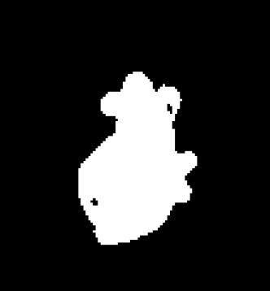 | 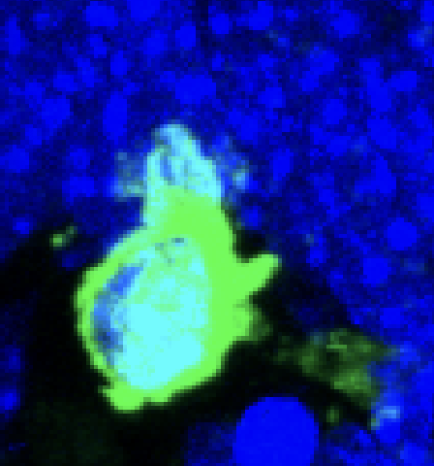
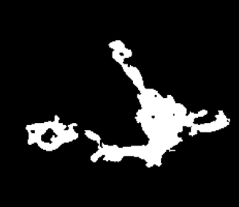 | 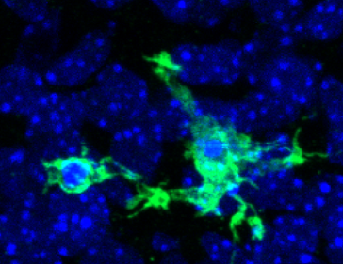  This is one microglia, the projection on the left is a phagocytic cup. The thresholding has separated it however, and as such the projection to the left should be removed as it is not a complete microglia.
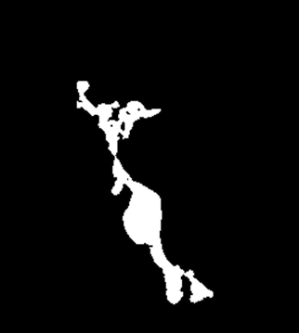  Some of the projection has been removed here, and while it appears likely that the green in the bottom right is part of the microglia, it is impossible to know for sure- so in this case the potentially simplified binary image is what we will use for data analysis. | 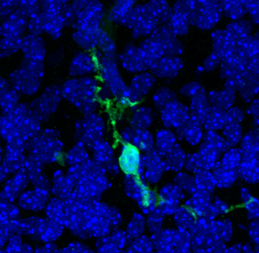

  - Examples of not defined nuclei:
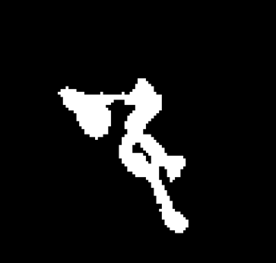 | 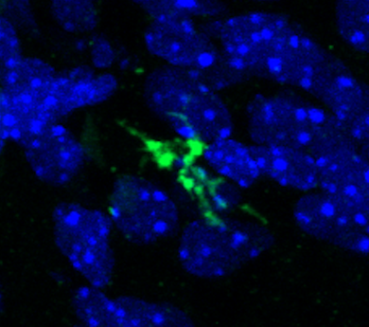
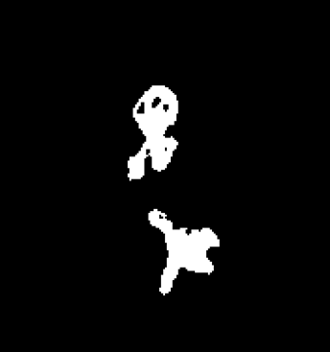 | 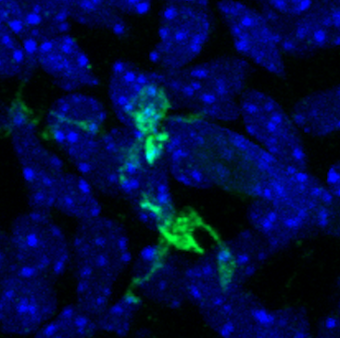
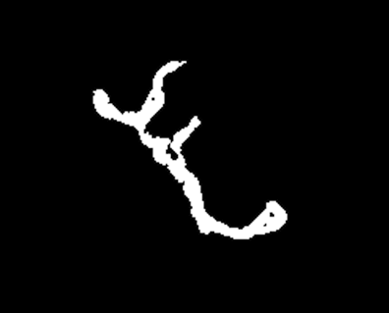 | 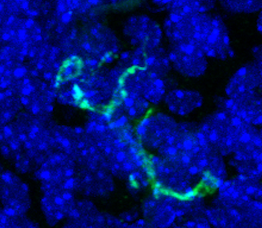
  The top two regions have a defined nucleus. The bottom does not and should be excluded. | 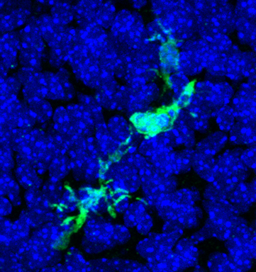

- Are there more than one nuclei?
  - If yes → proceed to step 4
  - If no → proceed to step 3
  - Examples of microglia with more than one nuclei, that will require some manual separation or exclusion:
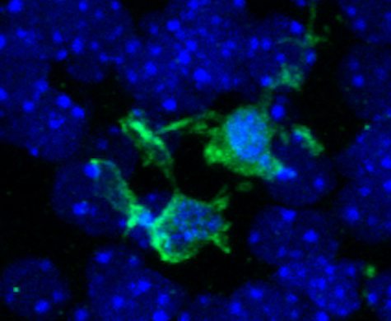 | 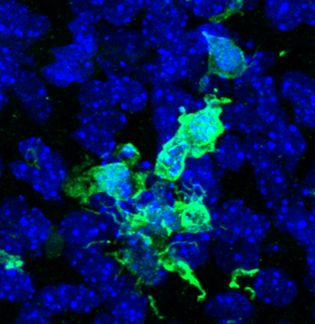
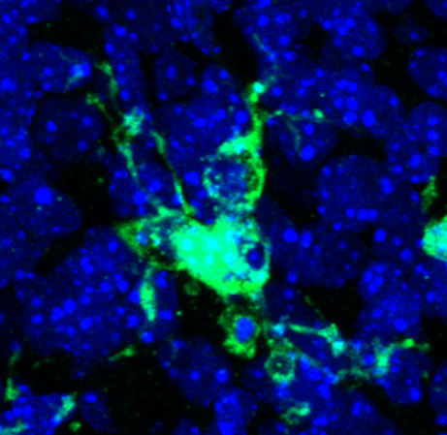 | 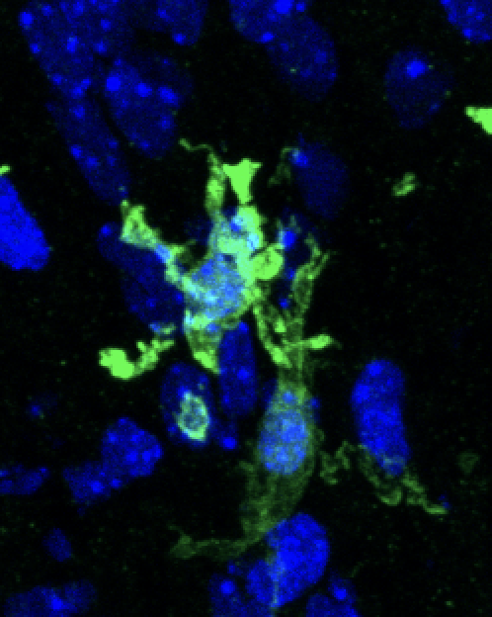

- Are main branches connected?
  - If yes → proceed to step 5
  - If no → consider removing the cell. Only remove if the programs binary conversion significantly changed the overall shape of the microglia (if 70-75% of the branches are retained you should keep the cell).
  - Examples of microglia with good branches:
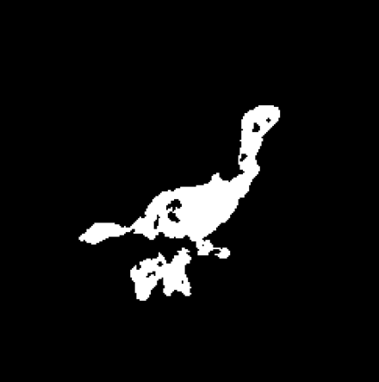 | 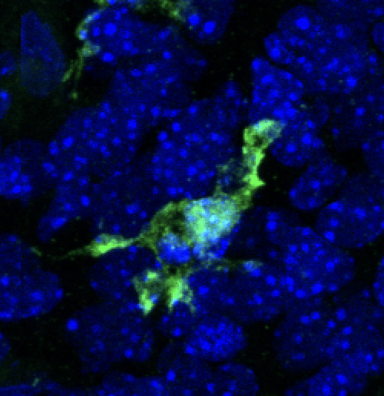
 | 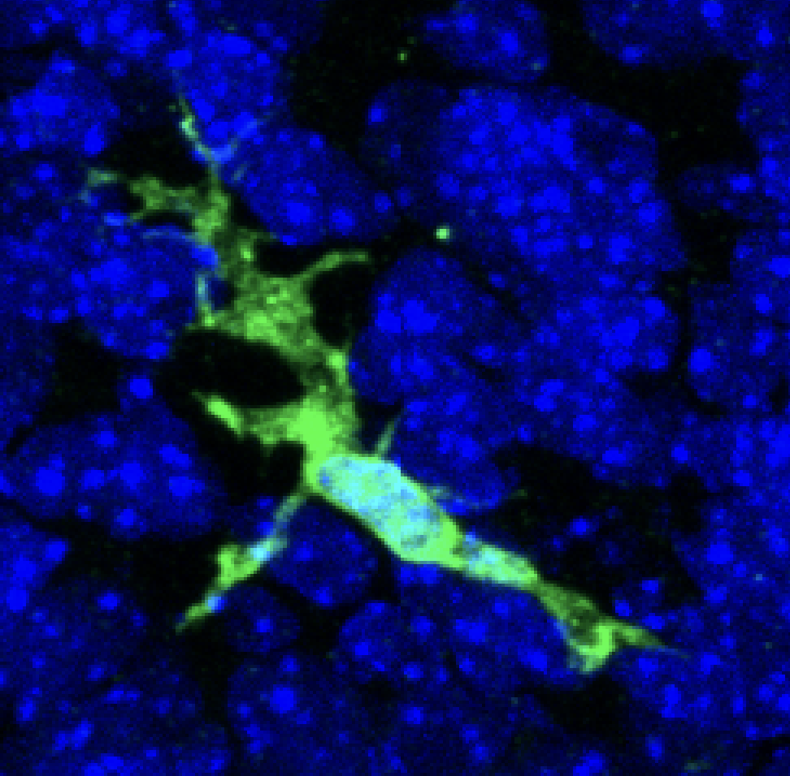
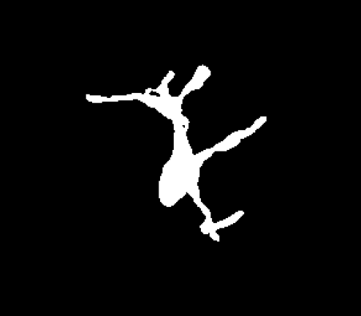 | 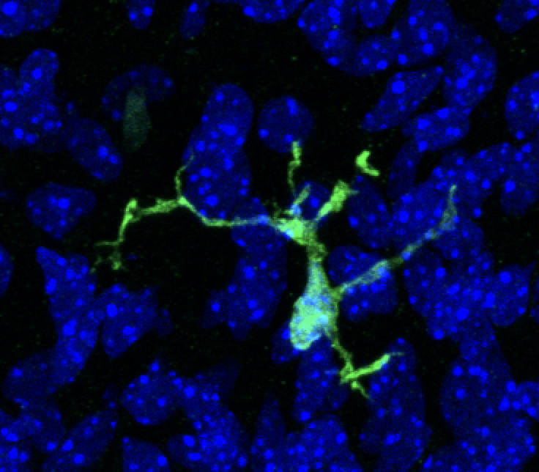

- If the program did not automatically separate the microglia use the paintbrush at 2px to separate the cell (see below for examples):
  - Be sure that: both regions have a defined nucleus and all main branches are attached. In cases where additional regions have been separated ensure that each has a defined nucleus (refer to earlier steps and examples as needed).
  - Examples of correctly divided the cells:
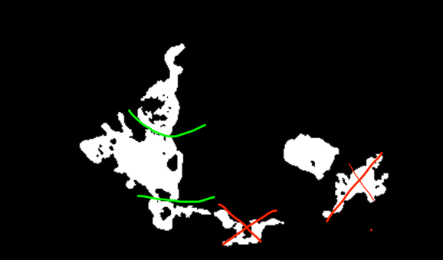 | 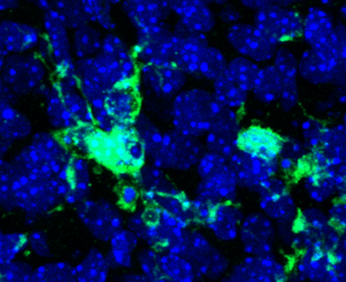
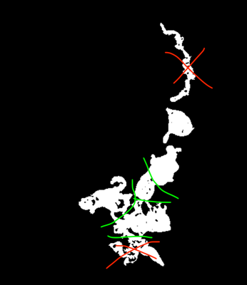  Here we divided the image into 4 sections, showing individual microglia (5 including the one already separated). The bottom portion was removed, as the binary image did not seem to accurately capture that area. The top one was removed due to lacking a nucleus. | 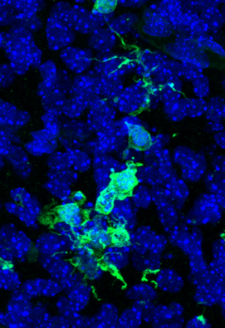
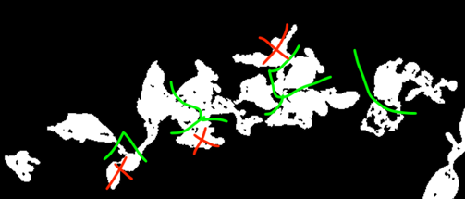 | 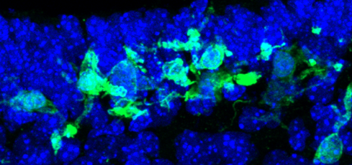

- Include the cell and move onto the next.

